Task

13/nov/2017

1. Set the sd card

* We had to clean sd card ** becareful (you need to clean all the file **including hidden file**)
* **Copy MLO file first** bcz ( in sd card it will go first place of particien) and than u-boot.img

to check these things are done try to boot with bbb. If it start to boot , it is fine.

* Copy the other files.

**(xxx@ubuntu:~/Documents$ cd buildroot-2016.05/output/images xxx@ubuntu:~/Documents/output/images $ sudo dd if=rootfs.ext2 of=/dev/sd2)**

1. Login id : root // ada

a) Which are the kernel parameters used to boot the system? Explain the meaning of them.

A: Virtual kernel memory layout

There are different parameters such as vector fixmap vmalloc etc in the layout

Pidmax : process id maximum also the min

b) What IP address has been assigned to BBB? Who is providing this IP? (**connect the eth cable and reboot**)

10:49:200:53. Cisco server DHCP(server)

c) How many processes are running in the Linux OS?

**only ps**  many

d) Which devices have been detected in the system boot?

**Cd dev**

**Ls**

Many i2c, tty (serial)

e) Try to access to BBB using putty with a ssh connection. First try to access with root account and later with another account. What happens? Find a possible solution to this.

BCZ we did not craeted account for BBB 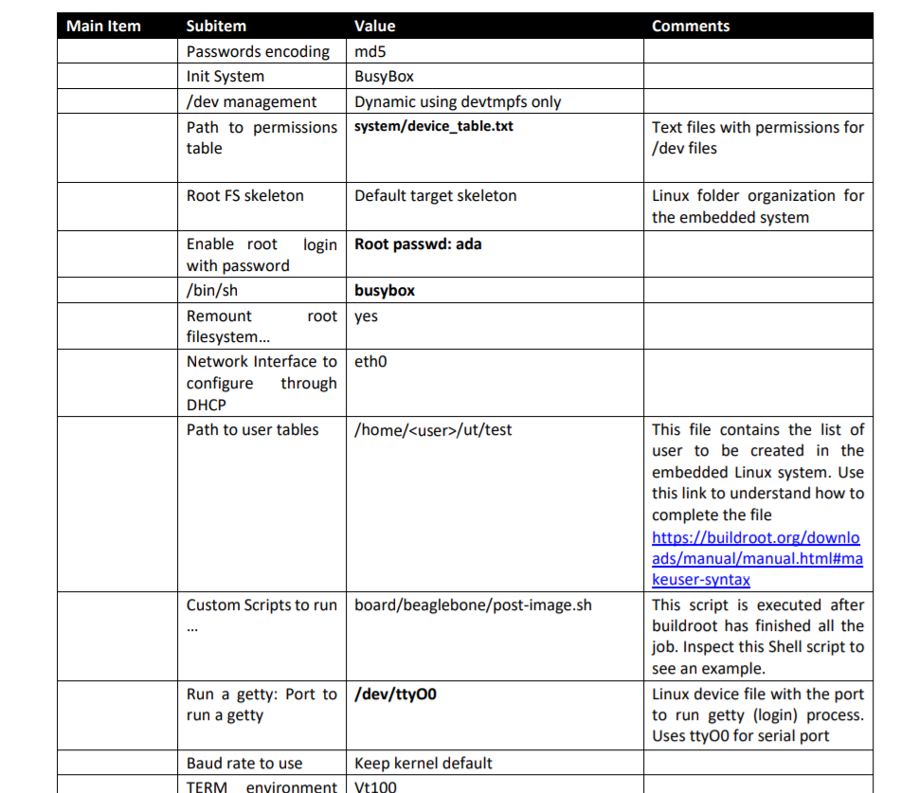

We will change the ssh configure to login with root with ssh google it (kind of hacking)